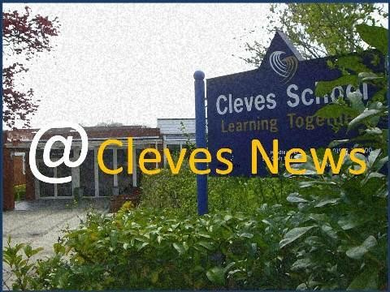

Headteacher’s Update – July 2024

Dear Parents and Guardians,

My final ever end of term letter will be my shortest ever newsletter. I simply wanted to thank you all.

As I prepare to retire and reflect on my time as the head teacher at Cleves I am filled with a genuine sense of gratitude and appreciation for the 10 years I have worked with you all. It has been an honour and a privilege to lead this wonderful school, and I am writing to express my heartfelt thanks to each of you for your unwavering support and partnership over the years.

Working at Cleves has been a truly rewarding and enjoyable experience and I am proud of our success. I know better than anyone that this success comes from a unique sense of partnership between staff, parents, pupils and trustees. I hope I have played a role but it is the collective efforts of the thousands of individuals involved with the school that makes Cleves so special.

The OFSTED outcome was the absolute test of this where we achieved the almost impossible by retaining outstanding. I can quote word for word what the team said to me when they arrived – “To gain outstanding we are looking for perfection. If we find a single element or subject that is not outstanding we cannot award it!! “

Towards the end of the inspector’s final meeting when the decision loomed, the lead inspector asked his colleagues if they had seen a single child off task at any point over the two days and if they had seen a single incident of concerning or unkind behaviour between pupils during their visit. Both answers were No. Every single parent, member of staff and pupil contributed to our OFSTED judgement which is truly remarkable.

Our school is a special place, and that is due in no small part to the strong, supportive community that you, as parents and guardians, have helped to build. Your commitment to your children’s education and well-being has been truly inspiring, and it has been a pleasure to work alongside you to provide the best possible learning environment for our students.

I am deeply grateful for the trust you placed in me and for the collaborative spirit that has defined our interactions. Together, we have navigated many challenges and celebrated numerous successes. Your involvement in school activities, your feedback, and your unwavering support have been invaluable in helping us achieve our goals and enhance the educational experience for all our students.

Your kindness, understanding, and dedication has made my role as head teacher an immensely rewarding experience. I have been continually impressed by the strength of our school community and the collective commitment to fostering a nurturing, inclusive, and high-achieving environment.

As I step down from my position, I am confident that Cleves will continue to thrive under new leadership. The strong foundation we have built together will undoubtedly support ongoing success and innovation. I am excited to see the continued growth and achievements of our students, staff, and school community.

Wishing you and your families all the best for the future.

Thank you once again.

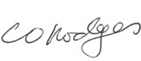

Mr C Hodges  
Headteacher