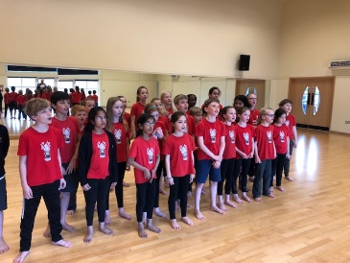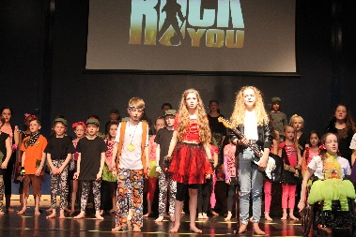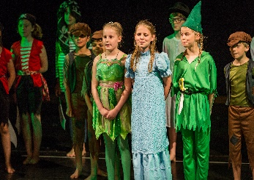  Dear Parent/Carer,  Theatre Works are proud to host drama classes at Cleves School.  During the term we will cover exciting topics in our drama sessions. The variety in our classes keeps children focused, enthused and after their stimulating classes they are alert and stretched mentally and physically. For the budding performers we can help them in all aspects of performance work and for other children we aim to increase confidence levels which will show in their school and social life. Most of all at Theatre Works we have fun through creative learning.  The spring term is our show term which will take place on Saturday the 29th of March 2025. Please be aware of this date at the time of booking as this is what our Tuesday group will be working towards.  Dates and classes for our spring term 2025:  Tuesdays: Year groups 5 and 6 - 3.30pm until 4.30pm.  Dates: Tuesday the 7th of Jan until Tuesday the 25th of March 2025. Fees for the spring term are £110.00. Theatre Works lessons for our upper school students take place in the performance hall.  To book a place please visit our website www.theatreworks.biz and head to the classes page where you will see Cleves Tuesday class. Once you have enrolled you will receive an email confirming your child’s place.  Places are limited and booked on a first come first serve basis.  Our Tuesday drama group at Cleves is a wonderful one, filled with happy and positive students.We look forward to welcoming new pupils for our 11thyear at Cleves School. For more information email jo@theatreworks.biz or call 07770 375344  Jo Russ  Principal Theatre Works   | Theatre Works  Drama classes for year groups 5 and 6  Enrolling now for our spring term.  Learn new skills in our exciting acting classes.  