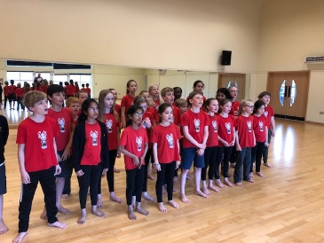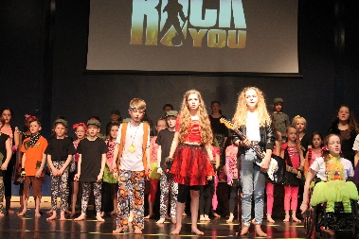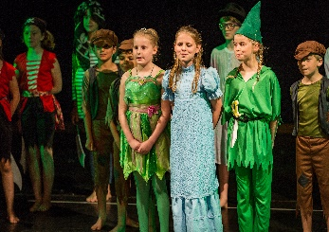  Dear Parent/Carer,  Theatre Works are proud to host drama and musical theatre classes at Cleves School.  During the term we will cover exciting topics in our drama sessions. The variety in our classes keeps children focused, enthused and after their stimulating classes they are alert and stretched mentally and physically. For the budding performers we can help them in all aspects of performance work and for other children we aim to increase confidence levels which will show in their school and social life. Most of all at Theatre Works we have fun through creative learning.  Each year all our students have performing opportunities. During the spring term we will be working on our show. The show will take place on Saturday the 29th of March. Please make sure your child is available for the show when booking (For more information look at our website www.theatreworks.biz)  Dates and classes for our spring term 2025:  Mondays: Year groups 3 and 4  Dates: Monday the 13th of Jan until the 24th of March 2025.  The class takes place in the dance studio and the fees for the autumn term are £110.00 Our group runs from 3.30pm until 4.30pm  Places are limited and booked on a first come first serve basis.  To book a place please visit our website www.theatreworks.biz and head to the classes page where you will see Cleves Monday class. Once you have enrolled you will receive an email confirming your child’s place.  This September will be our 11th year at Cleves and our drama group is a wonderful one, filled with happy and positive students. We look forward to welcoming new pupils for our spring term 2025. For more information email jo@theatreworks.biz or call 07770 375344  Jo Russ  Principal Theatre Works   | Theatre Works  Drama classes at Cleves year groups 3 and 4  Enrolling now for our Spring term.  Learn new skills in our exciting acting classes.  